|  |
| --- |
| Class:  Dog |
| Properties:  Breed: string  Colour: string  Size: string |
| Behavior:  Sit(): void  Run(): void  Jump(): void |

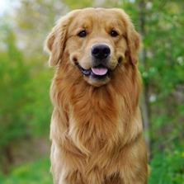



|  |
| --- |
| Class:  Rabbit |
| Properties:  Breed: string  Colour: string  Size: string |
| Behavior:  Eat(): void  Sleep(): void  Jump(): void |

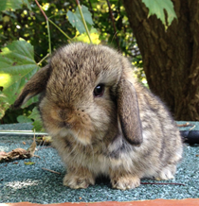

|  |
| --- |
| Class:  Television |
| Properties:  Brand: string  Model: string  Screen: string |
| Behavior:  Youtube(): void  Browser(): void  Share screen(): void |



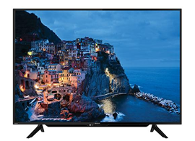



|  |
| --- |
| Class:  Oven |
| Properties:  Brand: string  Model: string  Capacity: num |
| Behavior:  Grill(): void  Defrost(): void  Lamp(): void |

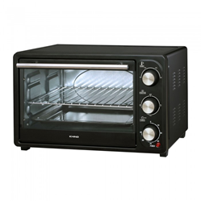



|  |
| --- |
| Class:  Water Purifier |
| Properties:  Brand: string  Model: string  Child safety lock: string |
| Behavior:  Hot water(): void  Ambient water(): void  Cold water(): void |

